**Python**

**Contents**

1. Introduction to Python
2. Applications of Python
3. IDEs
4. Introduction to Python Interpreter
5. Indentation and Comments
6. Keywords
7. Variables – Identifiers
8. Built-In Types
9. Assigning values to Variables
10. Input & Output Statements
11. Operators
12. Control Structures
13. Math & Random Modules
14. List
15. Tuple
16. Strings
17. Set
18. Dictionary
19. Functions
20. Files
21. Libraries in Python
22. **Introduction to Python**

**Why Python or What are the Advantages of Python:**

* Simple Syntax
* Length of code is very small
* Complex problems can be solved

**Difference between C, C++, Java & Python**

**Features of Python**

* Simple to Learn
* Open Source
* High Level Interpreter – Memory Management
* Object Oriented
* Standard Libraries
* Portability

**2. Applications of Python**

* Web & Internet Development
* Desktop GUI Applications
* Artificial Intelligence
* Image Processing Applications
* Machine Learning
* Business Applications
* Games & 3D Graphics
* Network Programming
* Database Access

1. **Integrated Development Environment (IDEs):** We can write the programs using below IDEs.

1. **Introduction to Python Interpreter**

**Source Code** is also called as Program which we write

**Compiler**: It is having Syntax & Rules (how to write and how we written) and it wont check logical errors. It checks only syntax. It would compile only if program completed. Here first program to compile and then execute to get output. Here it will convert to machine code once compilation completed

**Interpreter**: It can check logical errors and it compiles & execute the program line by line and it is not required to convert into machine code.

1. **Indentation and Comments**

To represent some block of statements, we need to follow the indentation. Following the margin is called Indentation. Program won’t execute if there is indentation error.

**Comments**:

1. Single line comments: # 2) Multi line comments: ‘’’ comment ‘’’ or “““comment “ “ “

1. **Keywords**

1. **Variables - Identifiers**

**Variable Name**

* A Variable is defined as an alternate name for memory location and can have a short name or a more descriptive name.

**Rules for Python Variables**

* A variable name must start with a letter or the underscore character
* A variable name can not start with a number
* A variable name can only have alpha-numeric characters and underscores (A-z, 0-9, and_)
* Variables names are case-sensitive. (name, Name and NAME are three different variables).
* Variable name should not match with keywords.

1. **Built-In Types (Data Types)**

1. **Assigning Values to Variables**

1. **Input () and Output Functions**

**Input ()**

**Output () or Print ()**

1. **Operators:**

1. **Control Structures:** Control Structures are also called as flow of control.

1. **Math & Random Modules:**

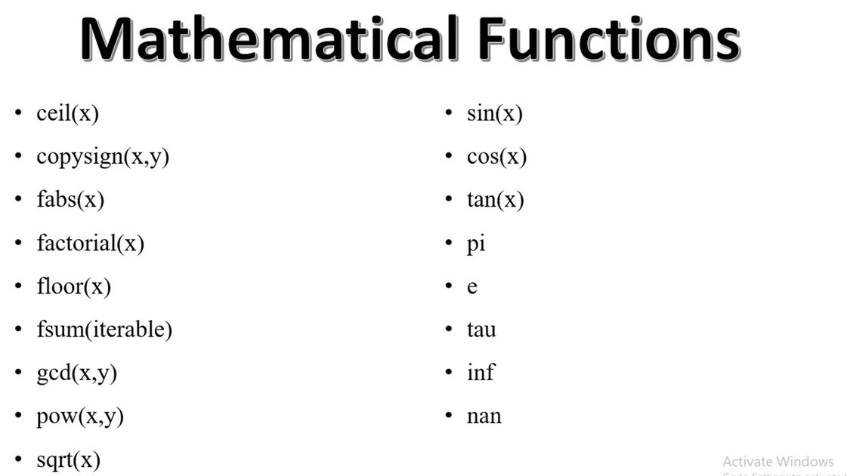

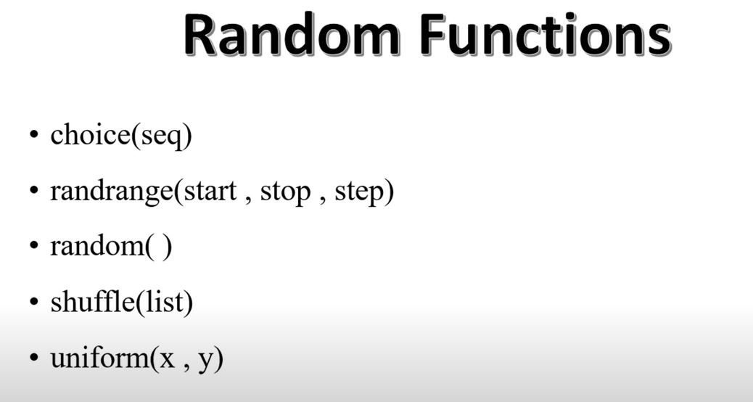

1. **List:**
2. **Tuple**
3. **Strings**
4. **Set**
5. **Dictionary**
6. **Functions**
7. **Files**
8. **Libraries in Python**